**L. VARSHINI**

**192372045**

**CSA1618 DWDM**

**EXPERIMENT-24**

**DATA SEGMENTATION BY COBWEB – HIERARCHIAL CLUSTERING ALGORITHM USING WEKA TOOL**

**AIM:**

To create data segmentation by cobweb-hierarchial clustering algorithm using weka tool.

**PROCEDURE:**

1. Download and install WEKA.
2. Open WEKA and Choose "Explorer" from the main menu.
3. Under Preprocess, Click on the open file button and select the dataset. Ensure that categorical attributes are in the correct format (nominal, not numeric).
4. Click on the "Cluster" tab. In the Cluster mode section, select "Use training set".
5. Click "Choose" (next to the cluster algorithm) and Select **Cobweb** (found under weka.clusterers).
6. Click on **"Cobweb"** to configure parameters: **acuity (Default = 1.0):** Controls cluster granularity (higher values lead to fewer clusters). **cutoff (Default = 0.002):** Defines the threshold for merging clusters (higher values result in more clusters).
7. Click **"OK"** and then **"Start"** to begin clustering. Click "Visualize" to see how the clusters are distributed. Save the file.

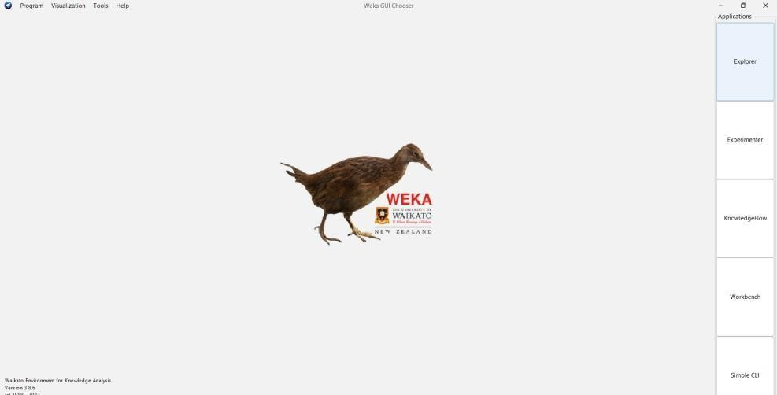

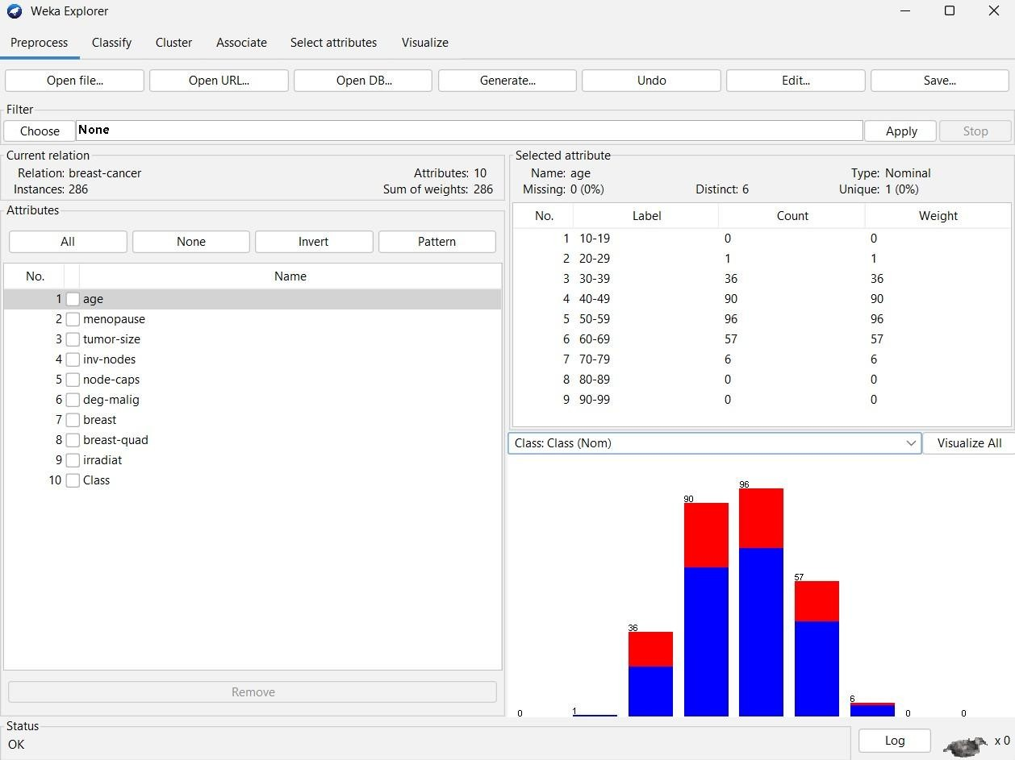

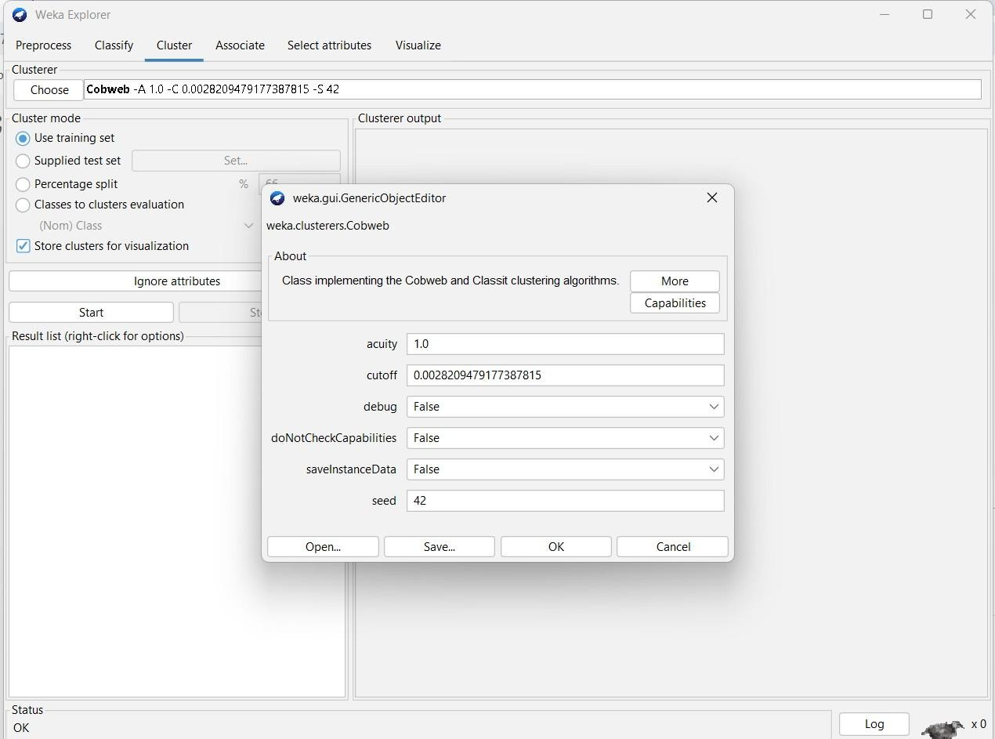

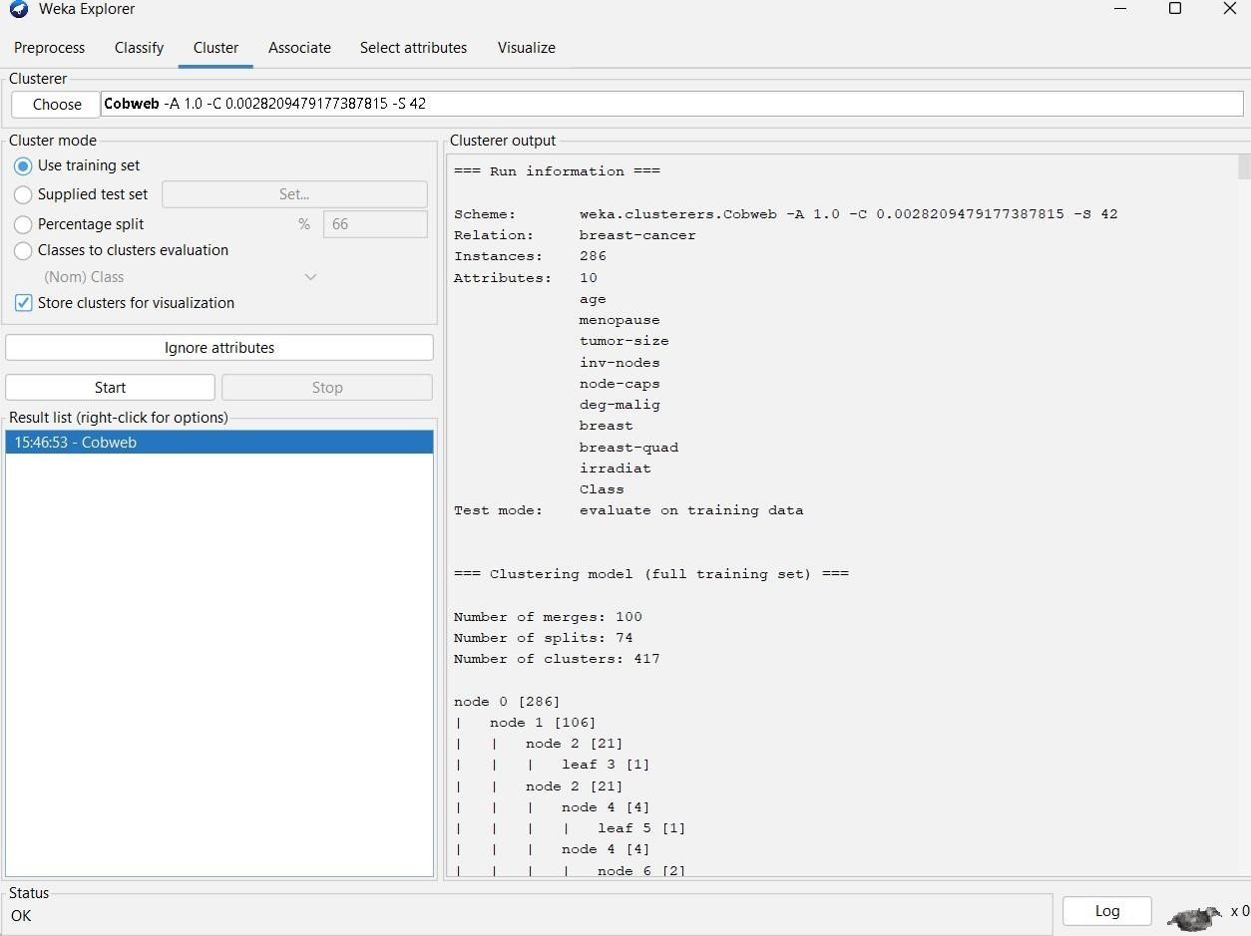

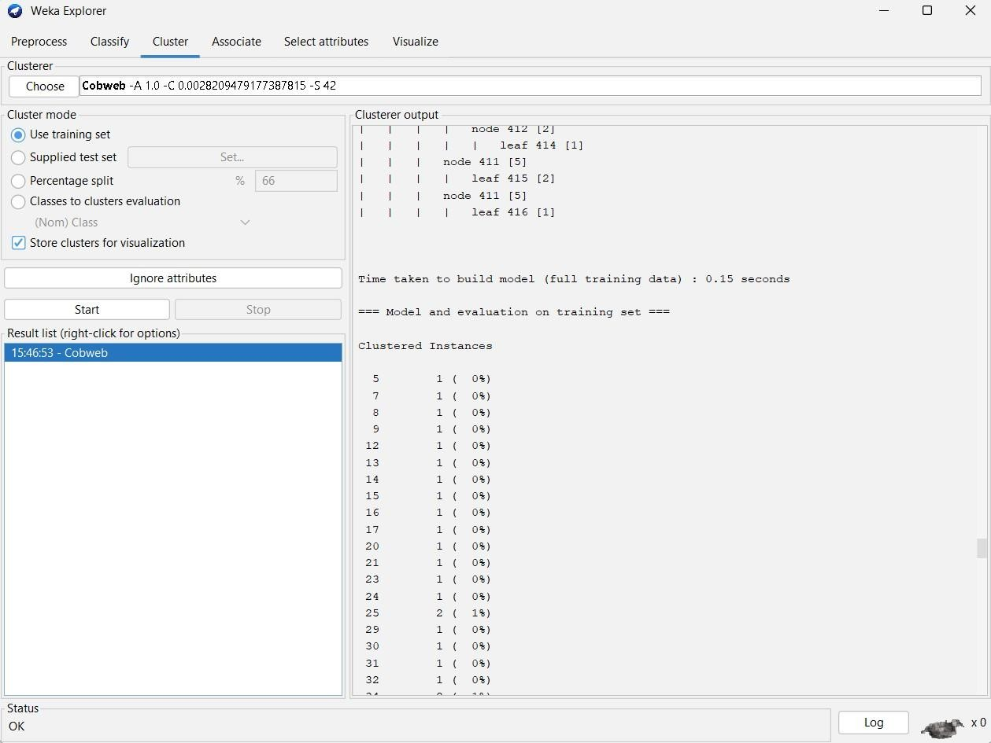

**OBSERVATION:**

=== Run information ===

Scheme: weka.clusterers.Cobweb -A 1.0 -C 0.0028209479177387815 -S 42

Relation: breast-cancer

**Instances: 286** Attributes:

10

age

menopause tumor-size invnodes nodecaps deg-malig breast breastquad irradiat

Class

Test mode: evaluate on training data

=== Clustering model (full training set) ===

**Number of merges: 100**

**Number of splits: 74 Number of clusters: 417** node 0 [286]

| node 1 [106]

| | node 2 [21]

| | | leaf 3 [1]

| | node 2 [21]

| | | node 4 [4]

| | | | leaf 5 [1]……………………………..

| | | node 411 [5]

| | | | leaf 415 [2]

| | | node 411 [5]

| | | | leaf 416 [1]

**Time taken to build model (full training data) : 0.15 seconds**

=== Model and evaluation on training set ===

Clustered Instances

5 1 ( 0%)

1. 1 ( 0%)
2. 1 ( 0%)
3. 1 ( 0%)
4. 1 ( 0%)
5. 1 ( 0%)
6. 1 ( 0%)
7. 1 ( 0%)
8. 1 ( 0%)
9. 1 ( 0%)
10. 1 ( 0%)
11. 1 ( 0%)
12. 1 ( 0%)
13. 1 ( 0%)
14. 2 ( 1%)………………… **PLOT:**

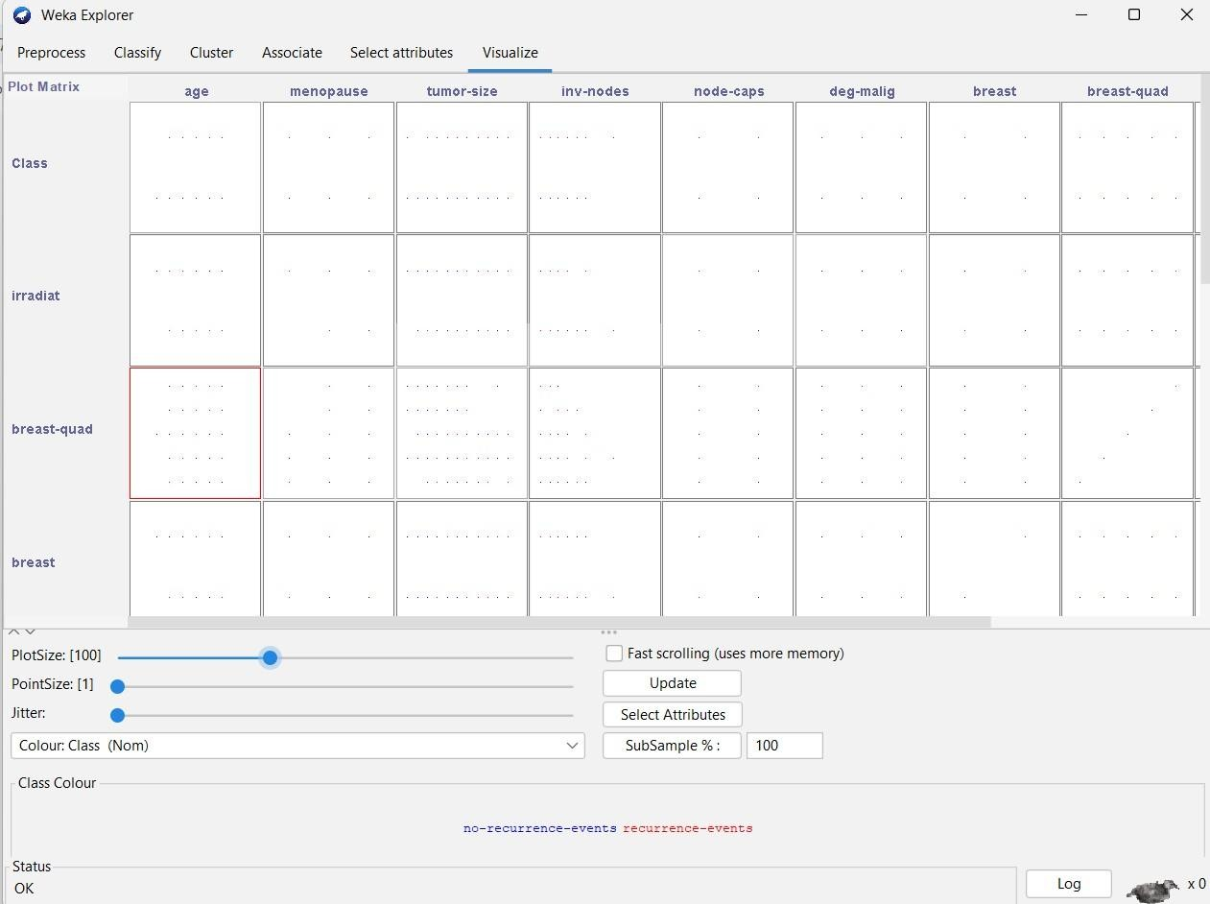

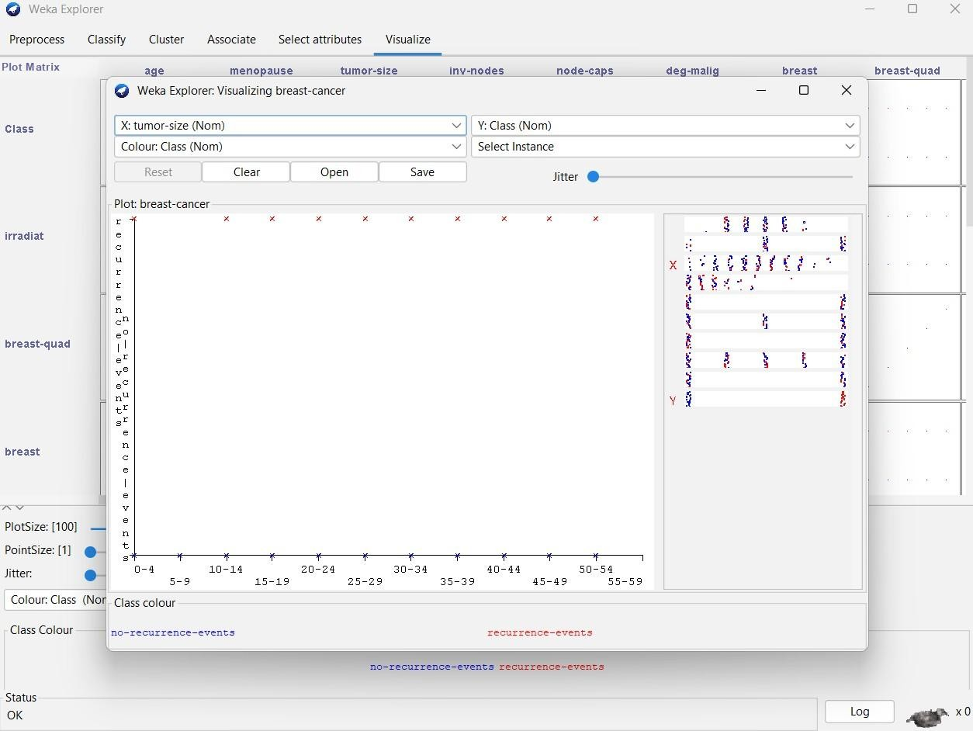

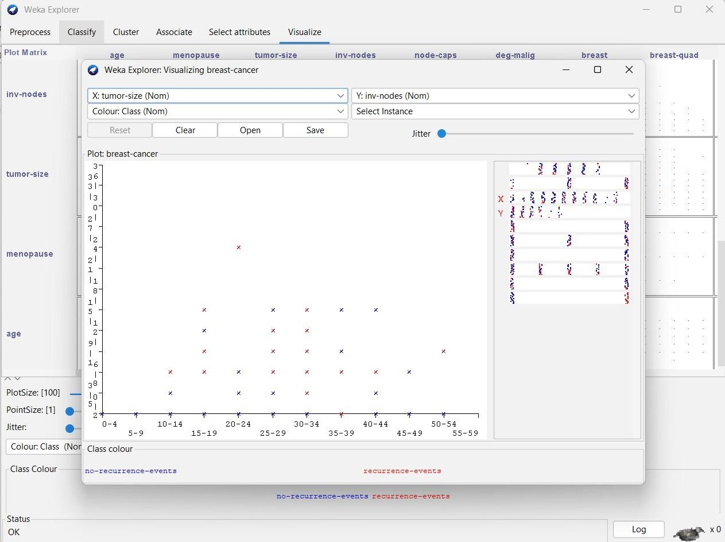

**RESULT:**

Thus, the data analysis of cobweb hierarchial clustering algorithm using weka tools has been analyzed and observed successfully.